SUMMERVILLE CREDIT UNION · CONSOLIDATED MEMBER GUIDE · CSUM-22 of 30
Personal Information Management

Module: nFinia Digital Banking > More > Personal Information
Sources: Summerville Reports Series A (36 docs) + Series B (25 docs) | Features: nFinia Documentation Features Spreadsheet
01 PRODUCT SUMMARY

The Personal Information section allows members to view and update their contact details, mailing and residential addresses, and manage trusted devices registered to their account. Keeping personal information current is essential for accurate OTP delivery, alert notifications, official correspondence, and identity verification.
The module is organised into tabs: Devices (trusted devices registered to the account), Contact Info (phone numbers and email addresses), Mailing Address, and Residential Address. Changes to sensitive contact fields (phone, email) require OTP verification using the existing contact before the new one can be saved.
Members managing their personal information through the app avoid the need for branch visits or phone calls for routine updates. Address changes, phone number updates, and email address changes can all be completed self-service within minutes.

At a Glance

Attribute | Detail
Module | More > Personal Information
Sections | Devices, Contact Info, Mailing Address, Residential Address
Verification | OTP required for phone/email changes
Trusted Devices | View, review, and remove registered trusted devices
Address Types | Mailing (for statements/cards) and Residential (for ID verification)
Related Reports | CSUM-28 (Device Management), CSUM-25 (Settings), CSUM-01 (Login)

02 KEY USE CASES

Use Case | Who Uses It | What They Do | Business Value
Update Phone Number | Member with new mobile number | Edit Contact Info > update phone number > verify via OTP | Ensures OTP and SMS alerts reach current phone number
Update Email Address | Member with new email | Edit Contact Info > update email > verify new email | Keeps email-based OTP and eDocument notifications functional
Update Mailing Address | Member who has moved | Edit Mailing Address with new address details | Ensures statements and cards are sent to the correct address
Verify Address on File | Member checking CU records | View Mailing and Residential Address screens | Quick audit without calling the CU branch

03 STEP-BY-STEP GUIDE

Navigation: Dashboard > More > 'Personal Information'.

Step 1 — Start from Dashboard
The member begins at the Dashboard after logging in. The Dashboard displays all account balances, upcoming payments, quick-action tiles, and the top navigation bar with links to Accounts, Move Money, and More.
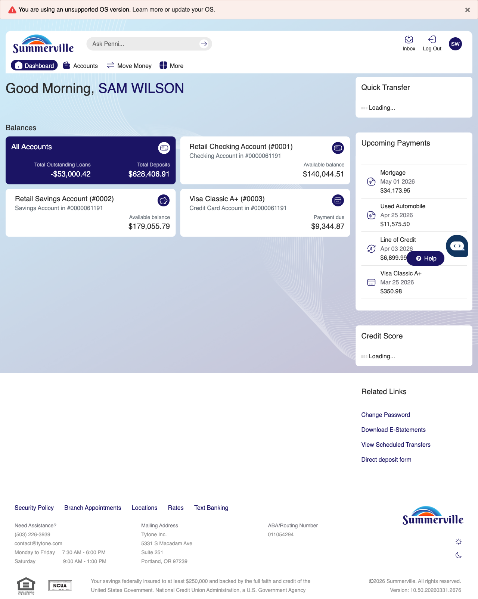
Step 1: Start from Dashboard

Step 2 — Open the More Menu
The member clicks ‘More’ in the top navigation bar. The More options panel expands to show additional features: Check Deposit, User ID and Password, eDocuments, Account Alerts, General Alerts, Password, Forms, One-Time Passcode, Skip A Pay, Do-Not-Disturb, Manage Devices, My Insights, Alert Settings, Recent Activities, and Card Services.
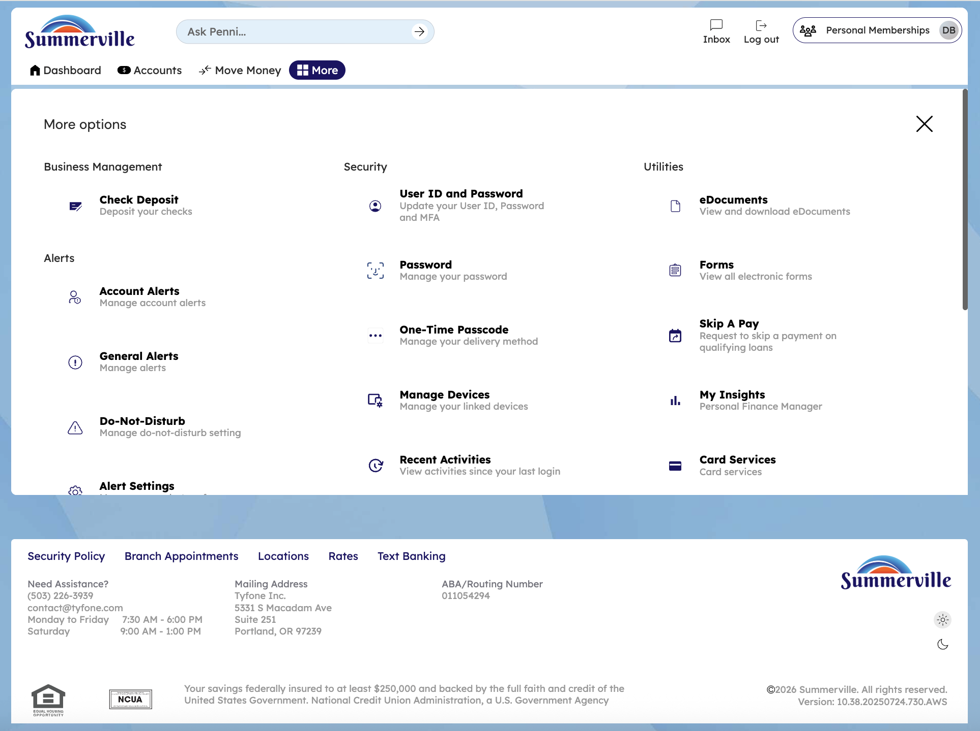
Step 2: More Menu

Step 3 — Navigate from Dashboard to Personal Information
The Personal Information page is displayed showing the Devices tab. A list of registered devices is shown, each with a 'Forget Device' button for removing access.
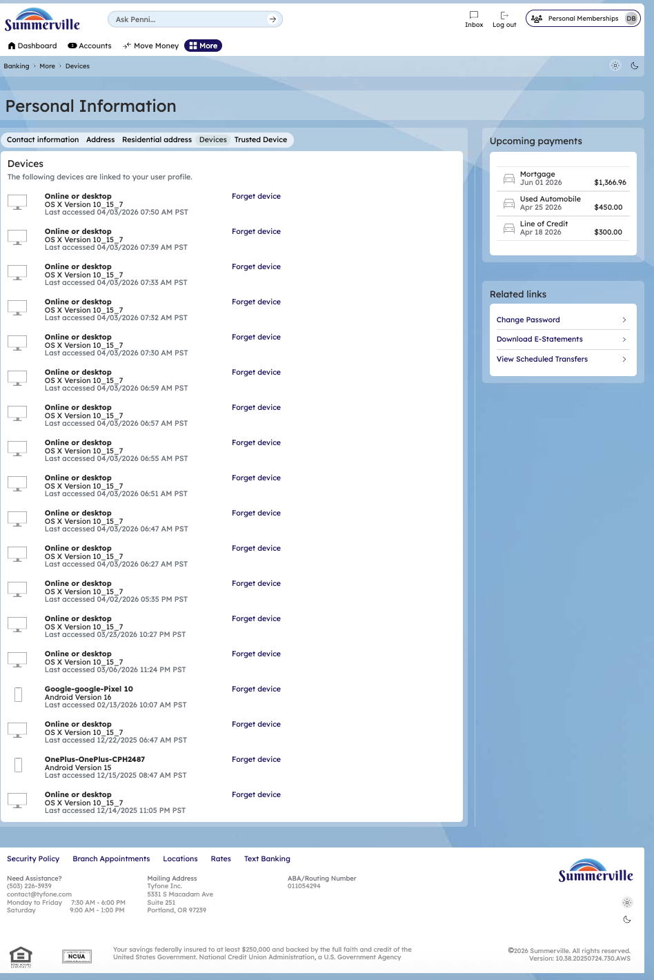
Step 3: Navigate from Dashboard to Personal Information

Step 4 — View Contact Information
The Personal Information page shows the Contact Information section displayed in a form format with various fields for phone numbers and email addresses.
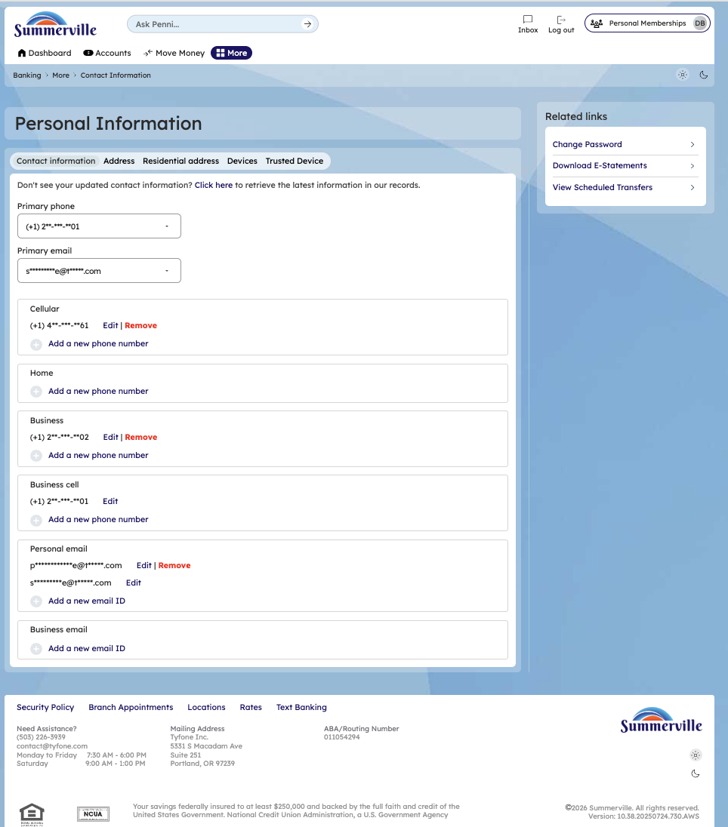
Step 4: View Contact Information

Step 5 — View Mailing Address
The Mailing Address section displays the member's current address at 5841 INDEPENDENCE DR, UTICA, MI 48451-7871 with an 'Edit addresses' button available.
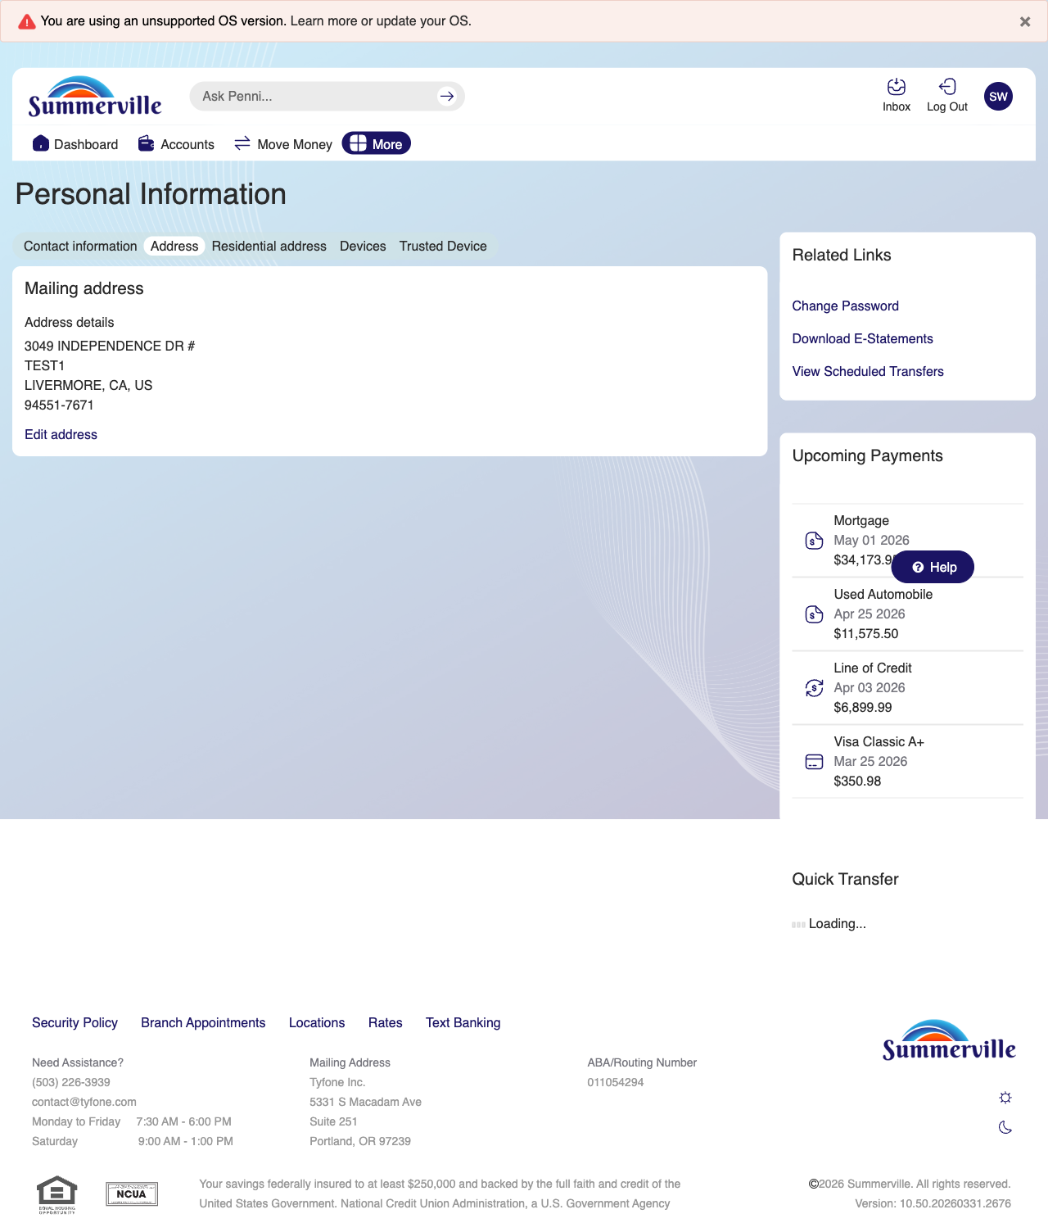
Step 5: View Mailing Address

Step 6 — View Residential Address
The Personal Information page shows tabs for Contact Information, Address, Residential Address, Devices, and Trusted Device. The residential address section is currently active.
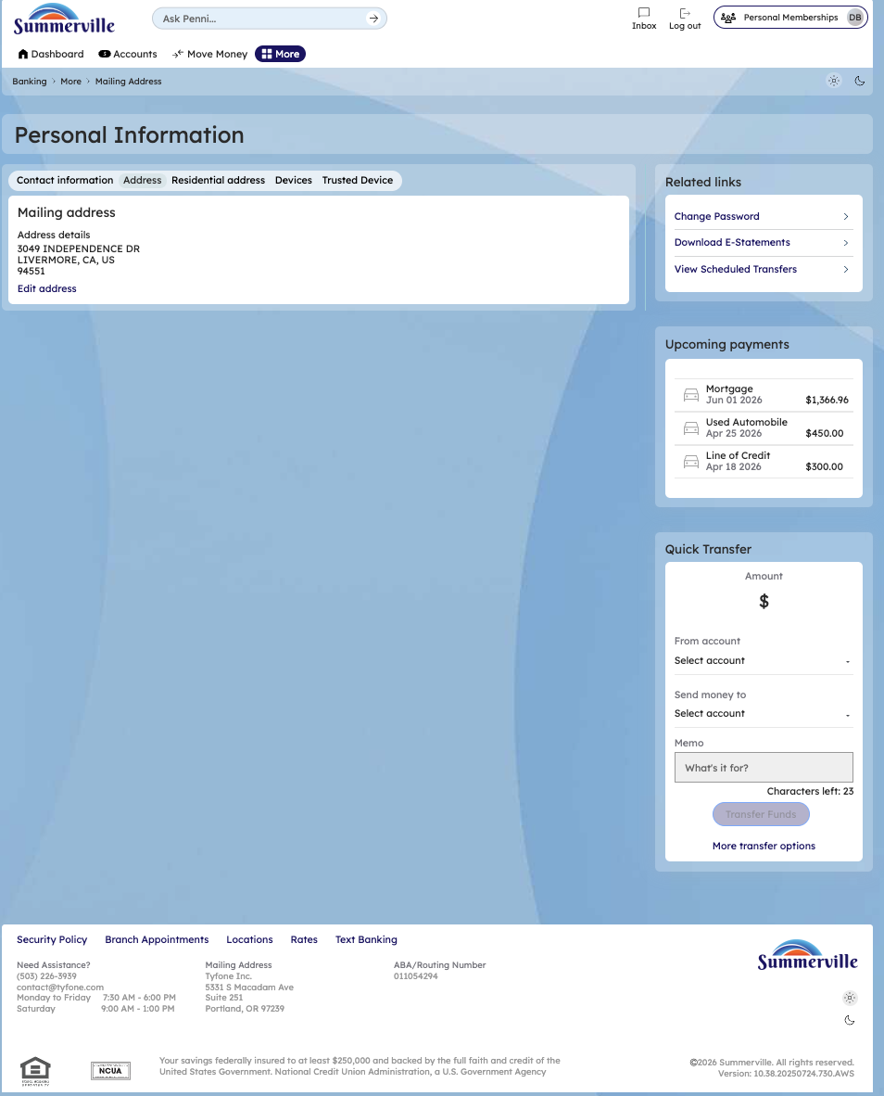
Step 6: View Residential Address

Step 7 — View Trusted Device Detail
The Trusted Device section is displayed with a shield icon and a message indicating the trusted device status has been successfully registered.
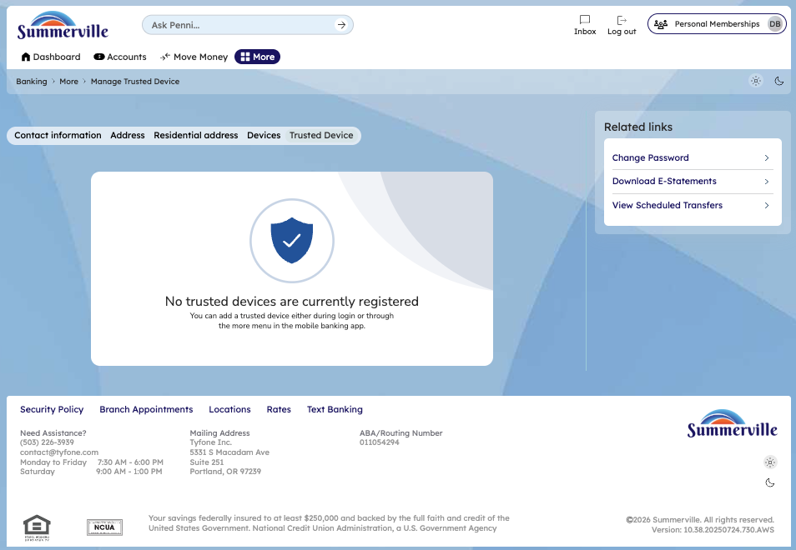
Step 7: View Trusted Device Detail

Step 8 — Edit Contact Information
The Personal Information contact editing form is shown with multiple input fields for updating the member's contact details such as phone numbers and email addresses.
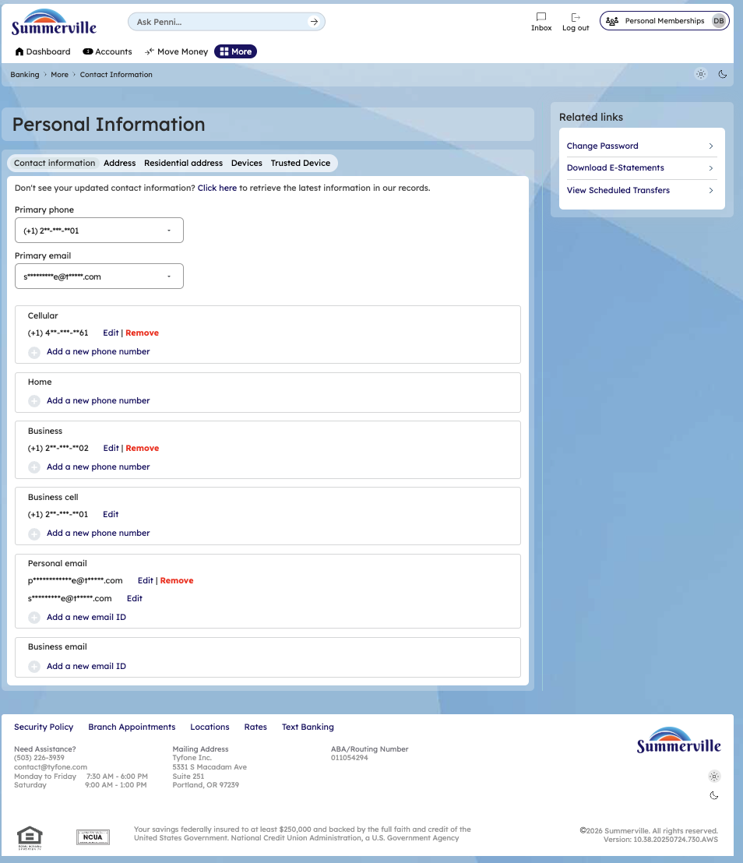
Step 8: Edit Contact Information

